Here are the easiest ways to check which Neo4j edition you're running on your Windows laptop.
Method 1: Using Neo4j Browser (Easiest)
This is the most straightforward method if you can start Neo4j.
- Start Neo4j (either through Desktop or using neo4j.bat console in command line)
- Open Neo4j Browser (usually at http://localhost:7474)
- Run this Cypher command:

CALL dbms.components()

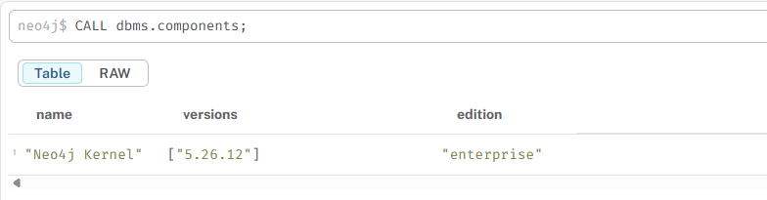

CALL dbms.components() YIELD name, versions
UNWIND versions AS version
RETURN name, version

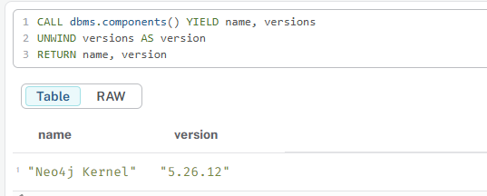

4.Look at the results - they will clearly show the edition:
  - Neo4j Kernel: Neo4j Enterprise = Enterprise Edition
  - Neo4j Kernel: Neo4j Community = Community Edition
You'll also see version information like 4.4.23 or 5.12.0.

Method 2: Using Command Line
If Neo4j is installed as a service or you can run commands:
- Open Command Prompt or PowerShell
- Navigate to your Neo4j bin directory (if it's in your PATH, you can skip this):
cmd
cd "C:\Program Files\Neo4j\neo4j-community-5.12.0\bin"
(Adjust the path to match your installation)
- Run:
cmd
neo4j.bat version

Method 3: Check Windows Services
- Press Win + R, type services.msc, and press Enter
- Look for services named "Neo4j"
- Right-click → Properties on the Neo4j service
- Check the "Path to executable" - it often contains "community" or "enterprise" in the path

Method 5: Using Neo4j Desktop (If you're using Desktop)
- Open Neo4j Desktop
- Look at your project and database
- The edition is usually displayed in the database details panel

DELETING A NEO4J DATABASE:

Method 1: For Neo4j 4.x & 5.x (Enterprise Edition or with multiple databases)
If you have Neo4j Enterprise Edition and have created testload as a secondary database, you should use Cypher commands.
- Switch to the system database to perform administrative tasks.
- Stop the database (if it's running).
- Drop the database.
You can do this in Neo4j Browser or Bloom:

// 1. Connect to the system database (often done via the UI dropdown)
// 2. Stop the database if it's running
STOP DATABASE testload;

// 3. Wait for it to stop, then drop it
DROP DATABASE testload;

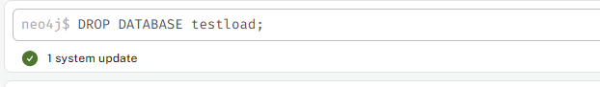

Important Notes for this method:
- You must have the necessary administrator privileges.
- You cannot drop the default neo4j database.
- If the DROP DATABASE command fails, make sure it's stopped. You can check its status with:
SHOW DATABASE testload;

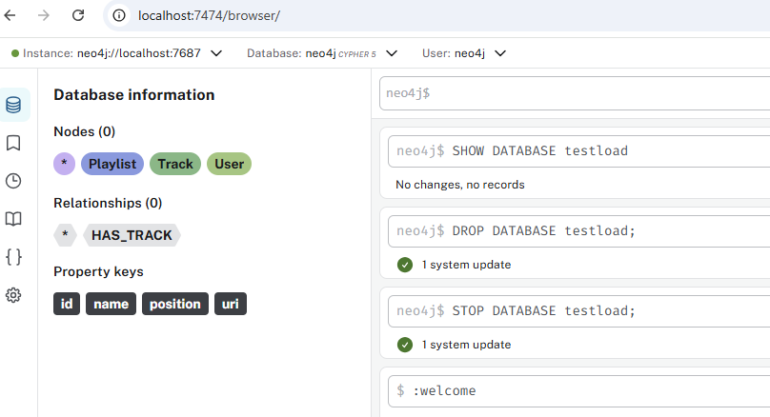

Method 2: For Neo4j Community Edition (or the default neo4j database)
The Community Edition only supports a single database per instance. To "delete" everything, you need to clear the entire graph.
This will delete all nodes, relationships, indexes, and constraints, giving you a completely fresh start.
Warning: This is irreversible. Double-check you're connected to the correct database instance.

// This is the nuclear option - it will delete EVERYTHING in your current database.
MATCH (n)
DETACH DELETE n;

What this does:
- MATCH (n): Finds all nodes n.
- DETACH DELETE n: The DETACH keyword first removes all relationships connected to the node, and then DELETE removes the node itself.

To also reset your constraints and indexes, you will need to drop and recreate them manually. You can see your current ones with:
SHOW CONSTRAINTS;
SHOW INDEXES;

Deleting indexes, relationships, and labels in Neo4j requires different Cypher commands. Here's a comprehensive guide for each.

1. Deleting Indexes
Indexes help with query performance but sometimes need to be cleaned up.
View All Indexes First
SHOW INDEXES

SHOW INDEXES YIELD name, type, labelsOrTypes, properties
WHERE name IS NOT NULL
RETURN name, type, labelsOrTypes, properties

Delete a Specific Index
DROP INDEX index_name

Method 2: Using APOC Library (If Available)
If you have APOC procedures installed, this works well:
CALL apoc.cypher.runMany("
SHOW INDEXES YIELD name
WHERE name IS NOT NULL
RETURN name
", {}) YIELD result
WITH result.name AS indexName
CALL apoc.cypher.run("DROP INDEX " + indexName, {})
YIELD value
RETURN count(*) AS indexesDropped
Method 3: Alternative APOC Approach
CALL apoc.cypher.runMany(
"SHOW INDEXES YIELD name WHERE name IS NOT NULL RETURN name;",
{}
) YIELD result
WITH collect(result.name) AS indexNames
CALL apoc.cypher.runMany(
"DROP INDEX " + apoc.text.join(indexNames, "; DROP INDEX "),
{}
)
YIELD result
RETURN result

Method 4: For Neo4j 5.x with UNWIND
Try this approach (works in some Neo4j 5.x versions):
SHOW INDEXES YIELD name
WHERE name IS NOT NULL
WITH collect(name) AS indexNames
UNWIND indexNames AS indexName
CALL {
WITH indexName
DROP INDEX indexName
}
RETURN count(indexName) AS droppedCount

Why This is Tricky:
- Neo4j's CALL {} subqueries have limitations on what commands can be inside
- SHOW commands are administrative and can't be nested in subqueries easily
- The syntax varies significantly between Neo4j versions

